Jarron Bailey

Homework 7

Date: March 07, 2019

**Test 1: Not enough characters = Failed**

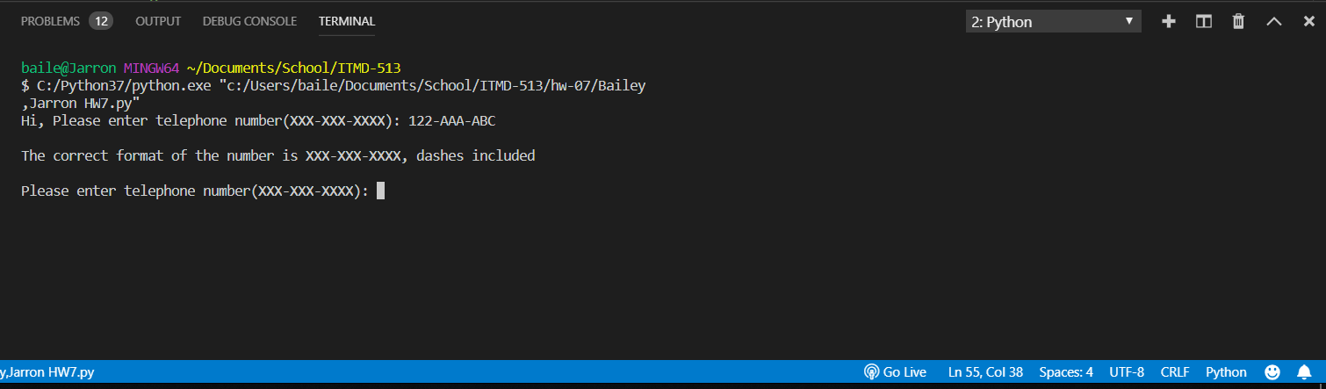

**Test 2: Special characters: “!” or “~” or “.” or “/” or “ ‘ “ = Failed**

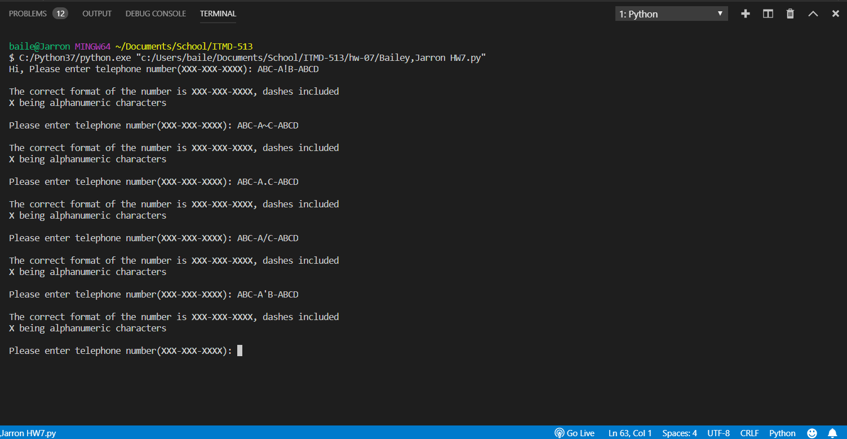

**Test 3: More than 2 dashes entered with alphanumeric characters = Failed**

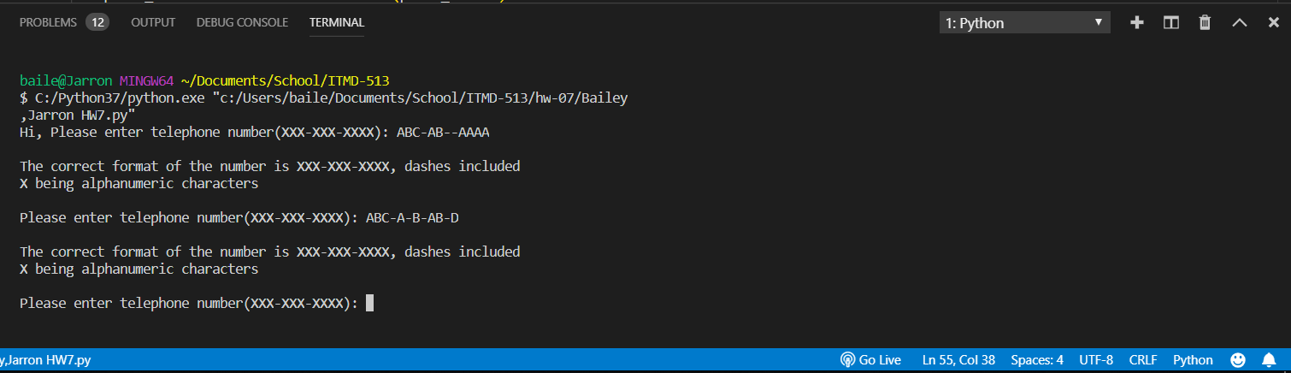

**Test 4: All letters capitalized = Passed**

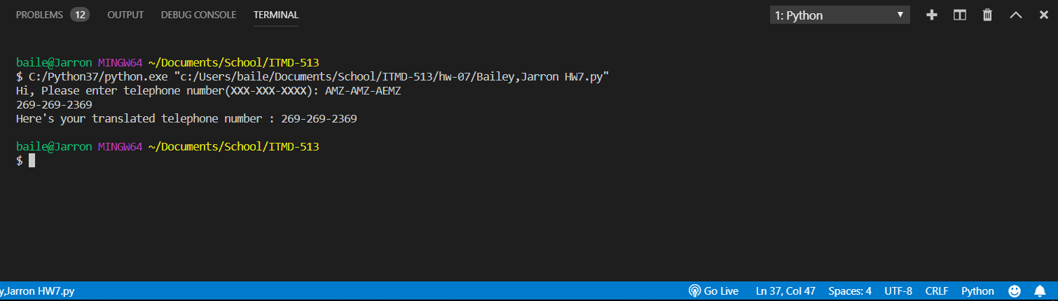

**Test 5: All letters lowercase (same letters from Test 4) = Passed**

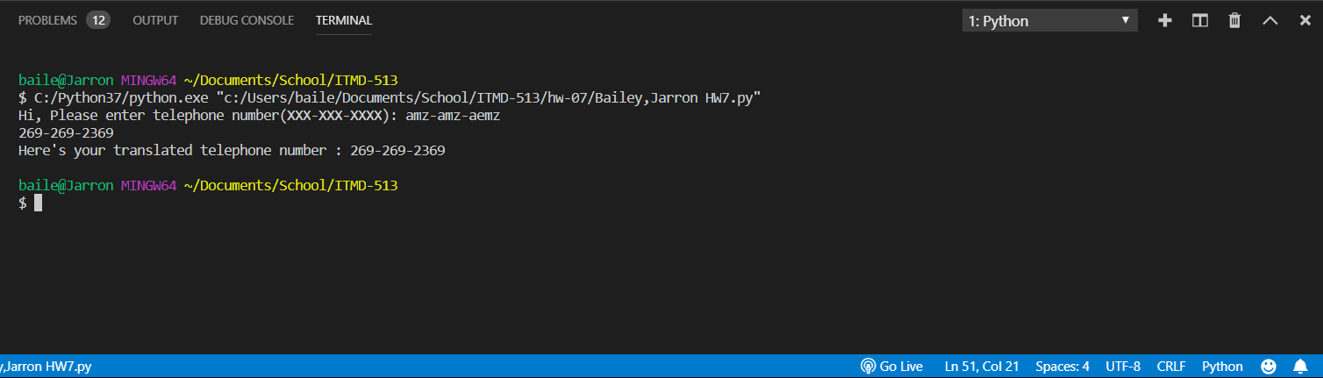

**Test 6: All numbers = Passed**

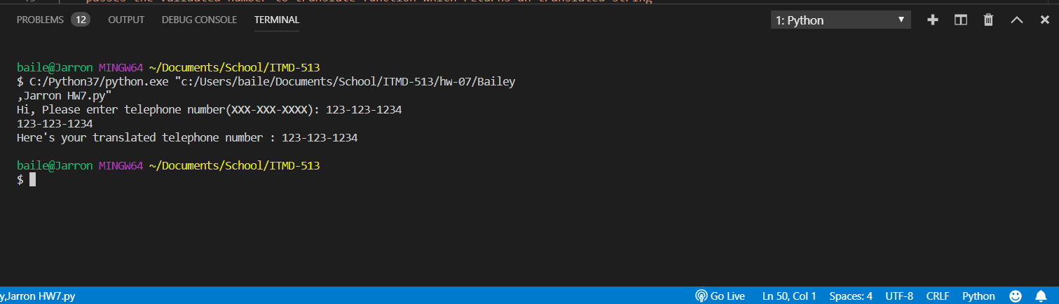

**Test 7: Mixed alphanumeric = Passed**

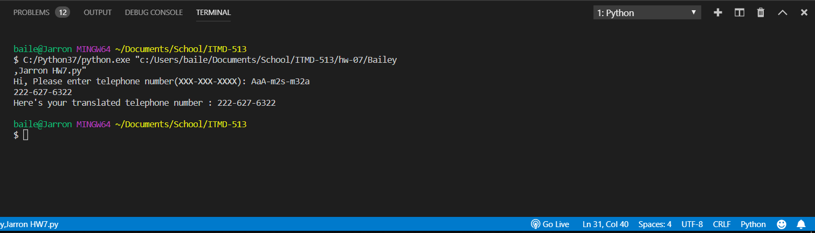

**Test 8: “555-GET-FOOD” = 555-438-3663 = Passed**

